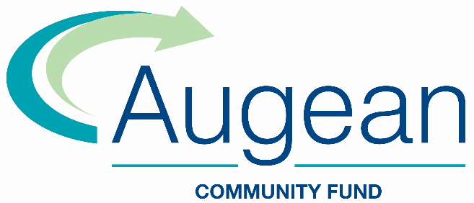
The Augean Community Fund is open to community projects within a 10-mile radius of ENRMF in Northamptonshire and Thornhaugh Landfill near Peterborough. There are two rounds of funding each year that allocate grants of approximately £500,000 per annum in total, up to a maximum of £50,000 for each project.
The current funding round will close to applications on 15 November 2023 with decisions on eligible projects by the end of January 2024. The deadline for the next round will be 15 May 2024 with applicants being notified by the end of July 2024.
The fund is managed by Grantscape with qualifying projects decided by local community volunteers on the Kings Cliffe Environmental Association (KCEA) and the Thornhaugh Environmental Association (TEA). Please contact: Grantscape, Office E, Whitsundoles, Broughton Road, Salford, Milton Keynes MK17 8BU Email: info@grantscape.org.uk Tel: 01908 247630 or visit:
www.grantscape.org.uk/fund/augean-community-fund/
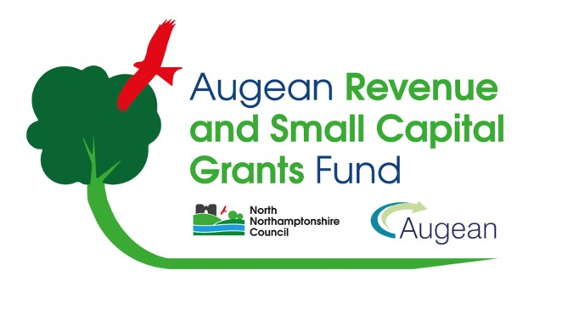
The ENRMF Fund was set up as part of the planning consent to accept Low Level Waste at the ENRMF site. Due to the changes to local government in the area, the responsibility for the ENRMF Fund has been transferred to North Northamptonshire Council and has been renamed and rebranded as the Augean Revenue and Small Capital Grants Fund.
Grants are available up to £5000 for capital costs and, unlike the Augean Community Fund, applications can also be made to cover running costs up to £10,000. Those within a 10-mile radius of the ENRMF site are eligible to apply, but with a preference to applications from within a 5-mile radius.
Applications are currently closed and will reopen in 2024.
To find out more or to apply please visit:
www.northnorthants.gov.uk/communities-and-grants/augean-revenue-and-small-grants-fund

In 2023, over £360,000 of funding was awarded through the Augean Community Fund to community projects and groups. These were:

Round 1
Ailsworth Parish Council Improvement of the Recreation Ground Facilities £32,518
Easton on the Hill Parish Council Permanent Power Supply to the Playing/Sports Field £10,000
Kings Cliffe & Area Community Sports Project Limited KC Active Environmental Sustainability £36,803
Langdyke Countryside Trust, Helpston New Community Nature Reserve £26,020
Manton Parish Council Manton Playground – New Equipment Provision Part 1 £34,212
Preston (Rutland) Village Hall Refurbishment of the Village Hall £35,000
Southwick Village Hall Sustainability Improvements £6,124

Round 2
Barnack Cricket Club Community Sports and Storage Shed £39,949
Langtoft Parish Council East End Pond Restoration £7,615
Nene Park Trust Construction of PlayZone Community Sports Facility £50,000
Peterborough City Rowing Club Facilities Extension and Kitchen Upgrade £50,000
Peterborough Lions Leisure Community Interest Company Multi Use Floodlit Artificial Football/Netball Pitch and Toilet (Bretton Park) £50,000
Peterborough Town Cricket Club Permanent Irrigation System to Reduce Water Waste & Volunteer Time £15,000

